PHY 134 Lab 9: e/m of the electron

By- Daniel Peterson
PHY 134 Section #7
TA- Yuan Hui Wu
4/28/15 12:00 PM: Taken
4/30/15 2:20 PM: Due

PART I - INTRODUCTION
Lab 9 involves observing the motion of charged particles in a magnetic field. An electron will be accelerated with a specified current and voltage and will begin to move. Due to the current generating a magnetic field, the motion of the electron will be circular. Since the charge over mass ratio (e/m) is constant, the motion of the electron is directly related to both the voltage and current applied.
Once an initial voltage level has been reached, the electrons will be guided in a circular path (determined by the magnetic field generated by Helmholtz coils). The magnetic field within the sphere holding the electrons is perpendicular to the plane of the coils. This means that the magnetic force acting on the electrons forces them to move in a circular path between the two coils. This phenomenon can be expressed with the following formula:
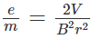
The V value is the voltage applied to the circuit, the B value is the magnitude of the magnetic field generated by the coils, and the r value is the radius of the circle in which the electron is traveling in. The magnetic field can be calculated by the following formula:
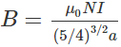
The u_o is a constant (4*pi * 10^-7), the N is the number of turns in the Helmholtz coils (130), the I is the current applied the coils, and the a is the radius of the Helmholtz coils. All of these values (aside from the current) remain constant throughout the experiment. By substituting this formula into the original formula, the following expression results:
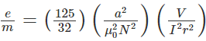

PART II – METHOD
The equipment used in this experiment is as follows:
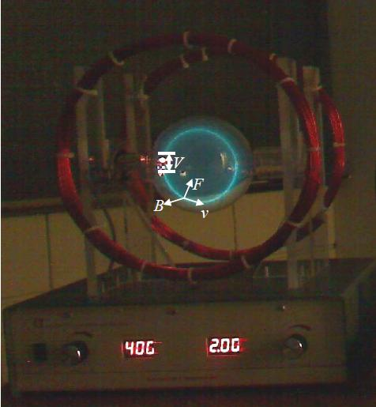
Figure 1 Apparatus used for the experiment
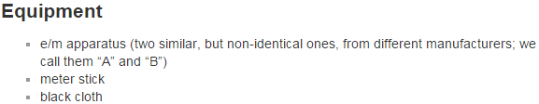
For the first part of the experiment, the relationship between the electron and the voltage/current applied will be observed. It should be noted that the voltage applied only affects the electron beam while the current affects the Helmholtz coils, neither affects the other piece of equipment. In order to start the apparatus, it must run a self-test upon power up for approximately 30 seconds. Once completed, two dials (one for voltage and one for current) will be available to turn in order to increase or decrease the voltage. Once activated, the electrons will emit a blue-green glow. This glow is caused by the ionization of helium which is present in the vacuum tube. This glow is very faint, so in order to observe it, the room must be dark and a dark cloth must be placed on top of the apparatus.

For this experiment, the lab manual suggested that the initial voltage be set to 150V and the initial current be 1.2A. However, the electron did not appear to accelerate, so the voltage was increased to 250V where the electron was visible with a distinct radius. With this voltage kept constant, the current was increased in order to observe the relationship between current and the radius of the electron’s path. For the second part, the current was kept constant at 1.2A and the voltage was increased in order to observe the relationship between voltage and the radius of the electron’s path.

After observing these relationships, the measurement of the radii of the electron paths at different voltage levels was determined. By using these values and the previously measured values, the value for e/m can be verified.
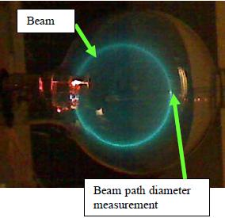
Figure 2 Electron beam and measurement tool to measure radius

PART III – DATA ANALYSIS
For the first set of measurements, it was observed that as the current increased, the radius of the electron path decreased. This is likely because the magnetic field has a greater magnitude and the electron is held closer to the center of the sphere. This results in a smaller distance from the center of the coils and a smaller radius. When the voltage is increased, the radius of the electron path increased. This is likely because the increased voltage accelerates the electron more, giving it more energy to move and increases the radius.
A few measurements were taken for the radius of the Helmholtz coils. Since the coils are perfectly circular, the distance from the top to the bottom of one coil is equivalent to the distance from the left to the right of the coil. These measurements are represented by the following formula:
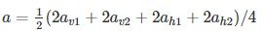
Each measured value is represented as 2a because they are diameters (diameter is 2 * radius). The values measured for the radii are:
Radius (m)
0.296
0.301
0.291
0.298
Table 1 Radius of Helmholtz Coils

By averaging these values together we get:
A = ½ (2*.296 + 2*.301 + 2*.291 + 2*.298) / 4
A = ½(1.186) /4
A = 0.14825m
Then, the current is held constant at 2A while the voltage is increased from a starting value of approximately 200V (chosen because that is the smallest voltage value where the electron path was visible) in increments corresponding to the radius of the electron path. Since the measuring stick within the tube had partitions of 0.5cm, the error in the measurements was determined to be half of that (±0.25cm). Each increment of the voltage corresponded to a 1cm increase in the diameter of the electron path (0.5cm radius increase). The following table is the results of the measurements:

Current(A) | Voltage(V) | Radius (m) | Diameter(m)
2.0 | 198 | 0.025 | 0.05
2.0 | 236 | 0.030 | 0.06
2.0 | 284 | 0.035 | 0.07
2.0 | 352 | 0.040 | 0.08
2.0 | 426 | 0.045 | 0.09
2.0 | 504 | 0.050 | 0.10

Table 2 Voltage, current, and radius values for 6 voltage increments

The delta radius for each value is ±0.00125 meters. This value is determined because the delta diameter is ±0.0025 meters (as discussed before, it is one half of the smallest measureable value), and the radius is one half of the diameter. Therefore, the delta radius is one half of the delta diameter. The delta r is present due to both the fuzziness in the beam for the electron path as well as limited precision from the measuring stick.
After measuring for the values of current and voltage, the voltage is written in the following form:
This constant is equivalent to the values from the earlier formula which remain constant throughout the entire experiment. By manipulating the formula, the following is achieved:
V = e/m * (Ir)^2 * (32/125)*(((4*pi*10^-7)^2 * N^2)/ a^2)
Constant = 3.119 *10^-7
V = e/m * (Ir)^2 * 3.119*10^-7
As it can be seen, the only variable remaining is r, since the current I, is a constant 2A and e/m is a constant. Since this is the case, and the radius is directly related to the voltage, there will be a linear increase in the (I*r)^2 value as voltage increases.
198 = e/m * 3.119*10^-7 * (2*0.025) ^2
198 = e/m * 3.119*10^-7 * 0.0025
198 / 5.3775 * 10^-10 = e/m
1.75122 *10^11 = e/m

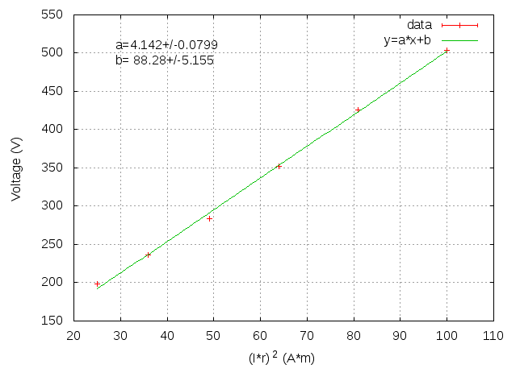
Figure 3 Graph of Voltage vs (I*r)^2
For e/m ,the e represents the charge on the electron. This value is constant at 1.602 * 10^-19. The m represents the mass of the electron, which is also constant at 9.109*10^-31. Therefore the total value of e/m is:
e/m = 1.602*10^-19 / 9.109*10^-31

e/m = 1.7587 *10^11
The value for e/m can be calculated with the formula we set up earlier.
e/m = (125/32) * (a^2 / u_o^2 * N^2) * (V / I^2*r^2)
e/m = (125/32) * (.148^2 / 4*pi*10^-7^2 * 130^2) * (352 / 2^2*.04^2)
e/m = 3296099 * (352 /4 *.016)
e/m = 801524 * (352 / .016)
e/m = 500953088 * 352
e/m = 1.7633538 *10^11
This value for e/m is very close to the actual value for e/m.
(1.7587 *10^11 - 1.7633538 *10^11) / 1.7587 *10^11 = -0.002646 = -.26% error

PART IV – DISCUSSION
For the first experiment, the current and voltage were observed to have two different relationships with the radius of the electron path. For the current, this was an indirect relationship, as the radius decreased for every increase in current. This is evident to us through the formulas for the voltage because the voltage (which is held constant) is equal to a constant divided by I^2*r^2. If the voltage divided by the constant doesn’t change, this means that the value of 1 / (I * r)^2 must also not change. In order to accomplish this, as one value increases, the other must decrease. Therefore, the radius decreases as the current increases and vice versa.
V = constant / (I*r)^2
V / constant = 1 / (I*r)^2
V / constant (when V is held at the same value) = new constant
Sqrt(New constant) = 1 / I*r
The reason for this is likely because with an increased current, the magnetic field has a greater magnitude and the electron is held closer to the center of the sphere. This results in a smaller distance from the center of the coils and a smaller radius. When the voltage is increased, the radius of the electron path increased. This is evident to us through the formulas for the voltage because the current (which is held constant) is multiplied by r and then squared. The result is then divided into a constant value and set equal to the voltage. If the voltage divided by the constant doesn’t change, this means that the value of 1 / (I * r)^2 must also not change. In order to accomplish this, the radius must change (as the current and other values cannot change). Therefore, the radius increases as the voltage increases and vice versa.
V = constant / (I*r)^2
V = constant / (I^2 *r^2)
Constant / I^2 (when I is held constant) = new constant
V = new constant * (1 / (r^2))
This is likely because the increased voltage accelerates the electron more, giving it more energy to move and increasing the radius of the electron path.

As far as errors are concerned, the values calculated for the voltage and current are fairly accurate (ie: errors are negligible). The value for the radius of the electron path is the only value being graphed which contains an error. This error is determined by one half of the smallest measureable value, but is also influenced by a natural fuzziness created by the ionized helium on the electron path. Despite this, the value for the radius of the electron path could still be measured with an accuracy of ±0.0025 meters. The value for e/m has a fairly large error (10^9 C/m scale), but it is not relevant when scale is considered. Since the value for e/m is very large, this error is fairly negligible.
(1.7587 *10^11 - 1.7633538 *10^11) / 1.7587 *10^11 = -0.002646 = -.26% error
As it can be seen, there is a quarter of a percent error in the value for e/m, which is a very small percent error. Finally, the value for the radius of the Helmholtz coils was calculated by measuring the diameter of the coil 4 times (twice vertically and twice horizontally). These values are then added together and divided by two in order to get the sum of the radii. Those radii are then divided by 4 (since 4 measurements were taken) in order to get the average radius. The error in the radius was calculated by the following formula:
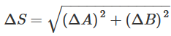
Since the error in each of the four radii was ±0.0025 meters, that value is used in the formula.
Delta r = sqrt[(0.0025)^2 + (0.0025)^2 + (0.0025)^2 + (0.0025)^2]
Delta r = sqrt(2.5*10^-5)
Delta r = 0.005 meters

